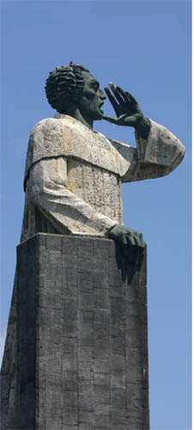
Fray Montesino, OP
Dominican Republic
Justice for Refugees: a call for restoration
The smile of one child, the tears of one parent, the grateful joy of one grandmother – these are the satisfactions of the refugee resettlement worker in the U.S. It is rewarding to assist the 35,000 Iraqis who have made their way to the U.S. in the past three years, and those thousands who are still to come. But it is also a task mired in bureaucracy, woefully underfunded, and wholly inadequate to the needs of the refugees who arrive with great hopes and high expectations.
Thirty years ago refugees arriving in the U.S. received an initial emergency cash grant of $425 per person and 36 months of cash assistance, medical coverage, food assistance, English language training and cultural adjustment support. The initial emergency cash grant has not increased in thirty years. Today’s refugees receive that same initial grant, and only eight months of cash, food assistance, and medical coverage. They are provided with six weeks of English language training and three months of caseworker-supported cultural adjustment programs, and are expected to self-sufficient within this 90-day period.
National Migration Week (Jan. 3-9) and World Day of Migrants and Refugees (Jan. 17) draws attention this year to the need for comprehensive and compassionate reform of U.S. immigration policy. They focus on the particular vulnerabilities of refugee and immigrant children.
For those wishing to help, attending to the needs of even one of the millions of Iraqi people displaced by war and persecution can be an act of restorative justice that reweaves the fabric of right relationship between the citizens of our two nations in a tangible, immediate way. From the earliest moment of our presence in the Americas, we Dominicans have been about this mission of healing and reconciliation. The same mission is urgently required of us still. The resource list that accompanies this reflection (see Iraq page at www.domlife.org) includes a link to contact information for every refugee resettlement program in the U.S. Contact the one nearest to you to find out how you can help.
Renewing Hope, Seeking Justice:
As a Dominican Family we…
Praise God for the gift of human diversity and the opportunity to serve the refugee newcomers to our shores.
Bless by seeking mutual blessing in relationship with even one Iraqi refugee through a sharing of our time, talent, or treasure.
Preach the already-but-not-yet reign of justice by advocating for meaningful immigration reform.
“Tell me, with what right, with what justice; on what authority have you waged such detestable wars on these people, in their mild, peaceful lands.” Hispaniola Homily, 1511

Prepared by the Iraq
Coordinating Committee
January 2010

